AWS Learner Lab Assignment: Creating a DynamoDB Table and Exporting It to an S3 Bucket Using Cloud9 (Pet Inventory Project)

Ishwariya pandi
ASU Id: 1233885850
Information Technology, Arizona State University
IFT 512: Advanced Big Data Analytics/AI
Durgesh Sharma
09/28/2025

PART A: Set Up Cloud9 & DynamoDB TableGoto cloud9 then create
“Qns 1: Sort key and partition key
Explain the difference between a partition key and a sort key in DynamoDB.”
“Ans:”
In DynamoDB, the sort key is used within that partition to arrange items in a defined order, enabling efficient queries like retrieving items by range or sequence. Together, they form a composite primary key that permits storing and accessing multiple related records under the same partition. The partition key determines the partition (physical location) where an item is stored, and all items with the same partition key are grouped.
“Qns 2: Screen Shots”
“Ans:”
1. Create environment
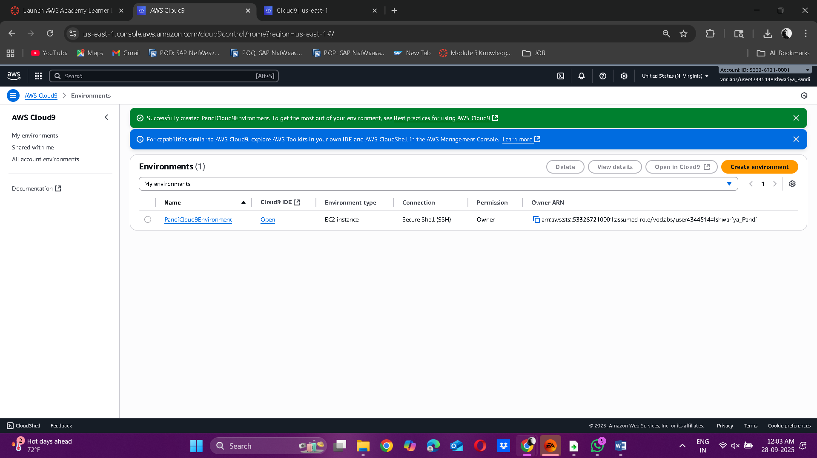

2. Open Cloud9 IDE
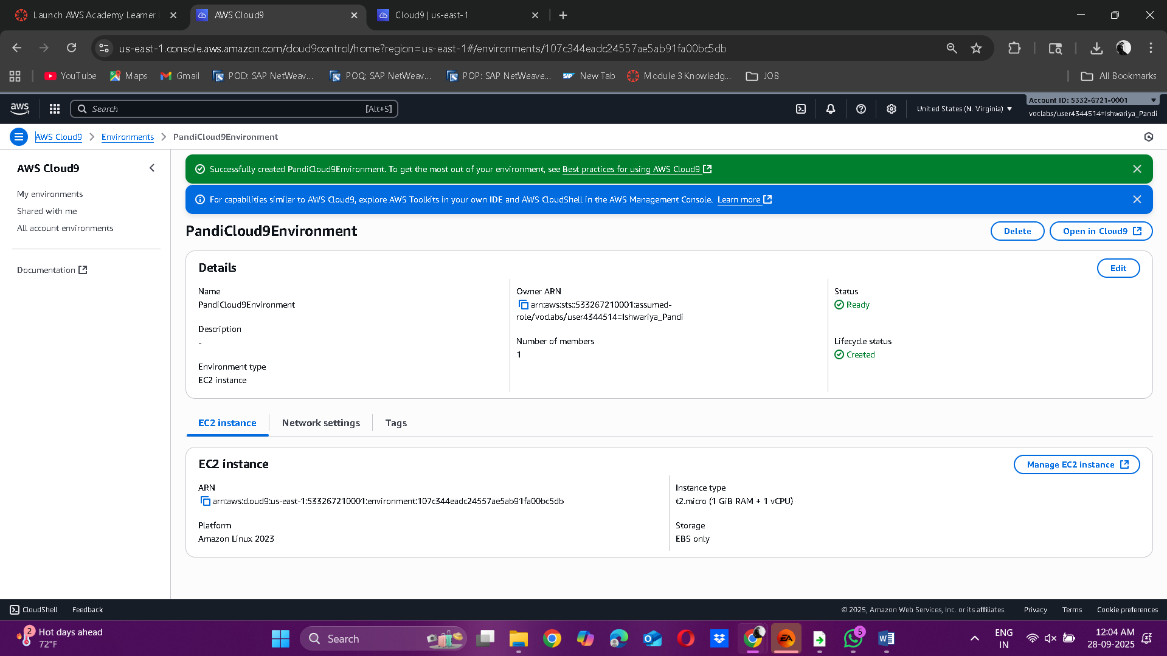

3. Install the Required Python Library
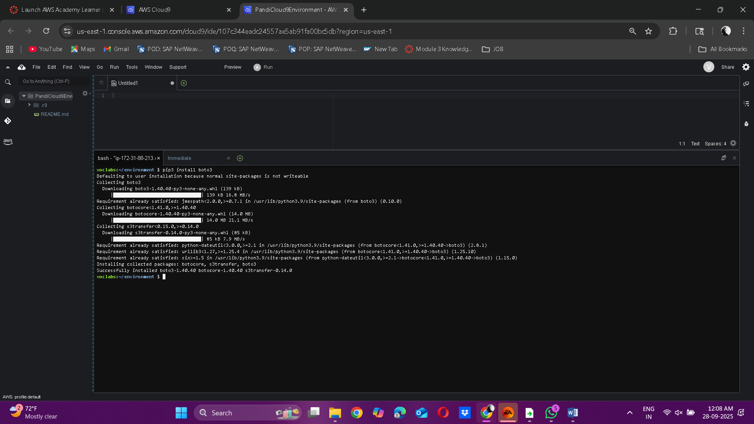

4. Create Your Working Directory
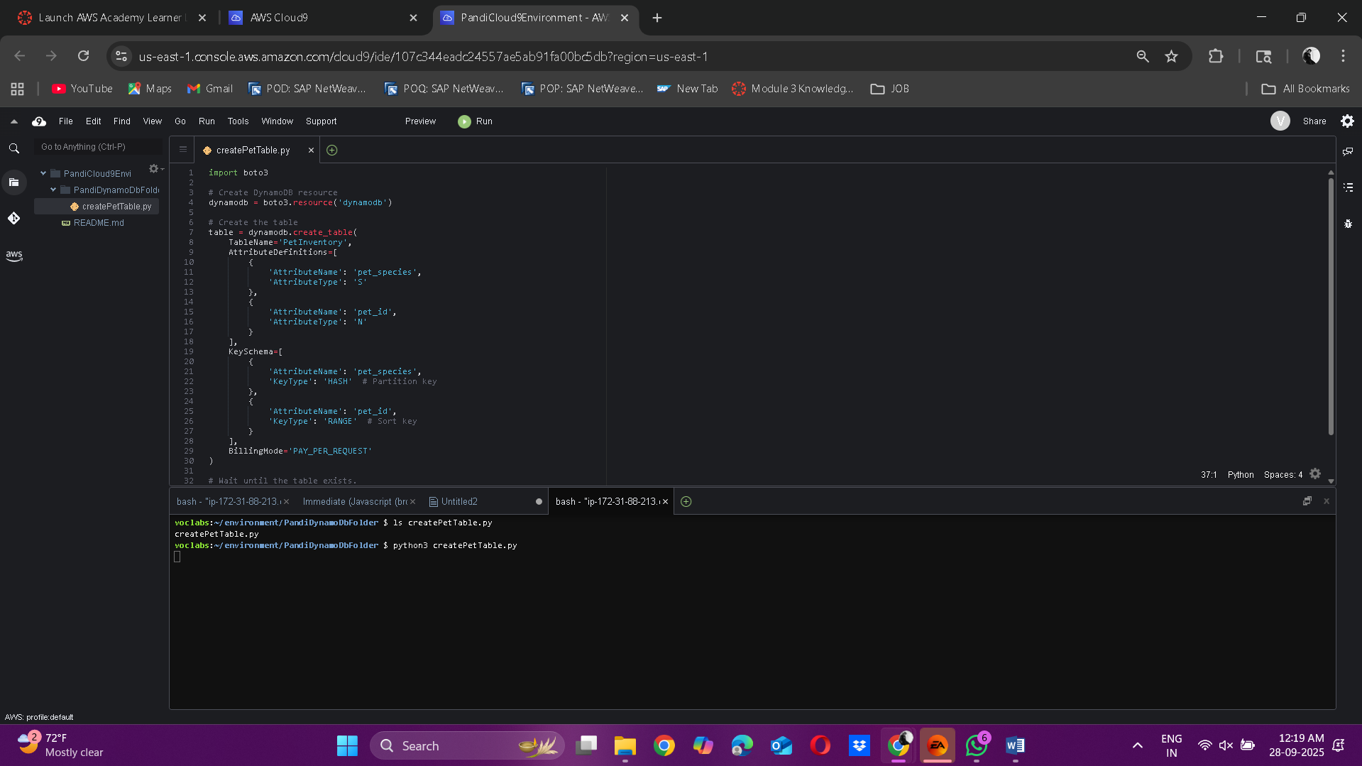

5. Create and Run createPetTable.py
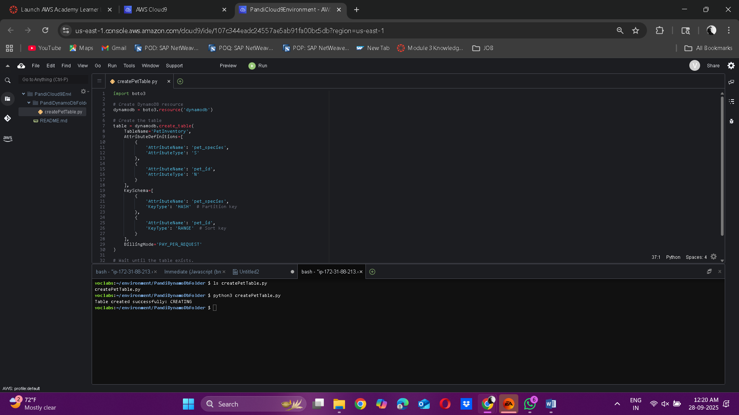
6.Verify the Table:
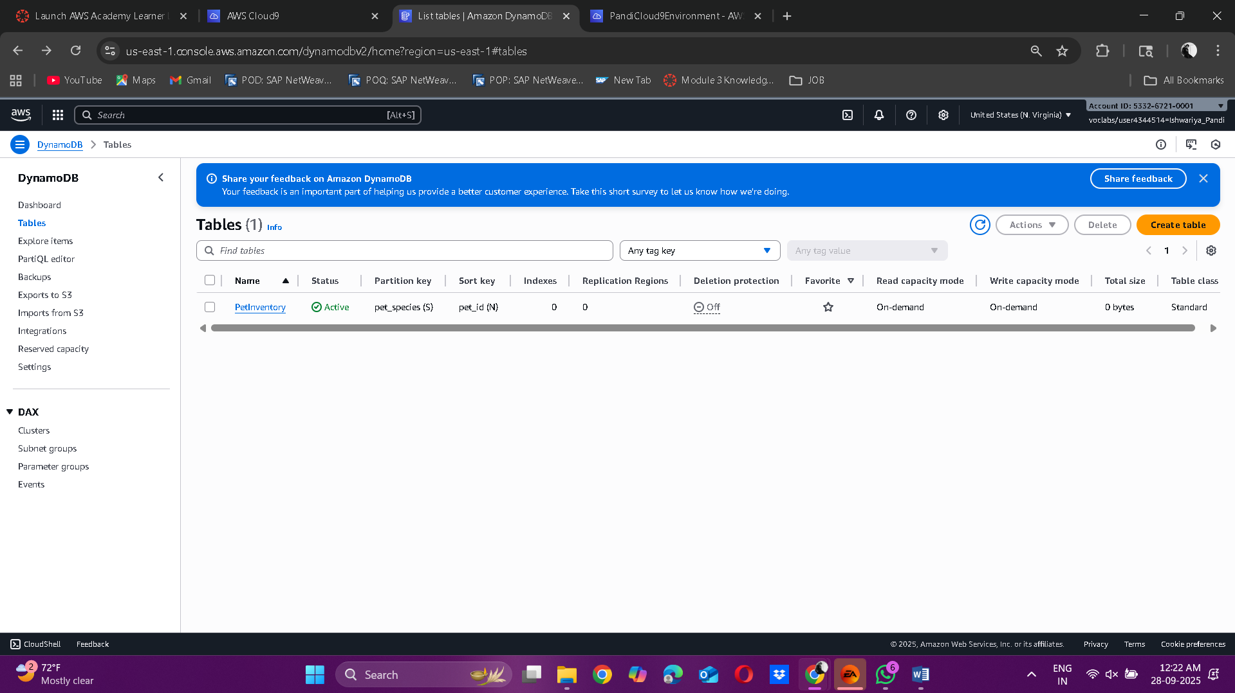

7. Explore the table and you will see no items in it.
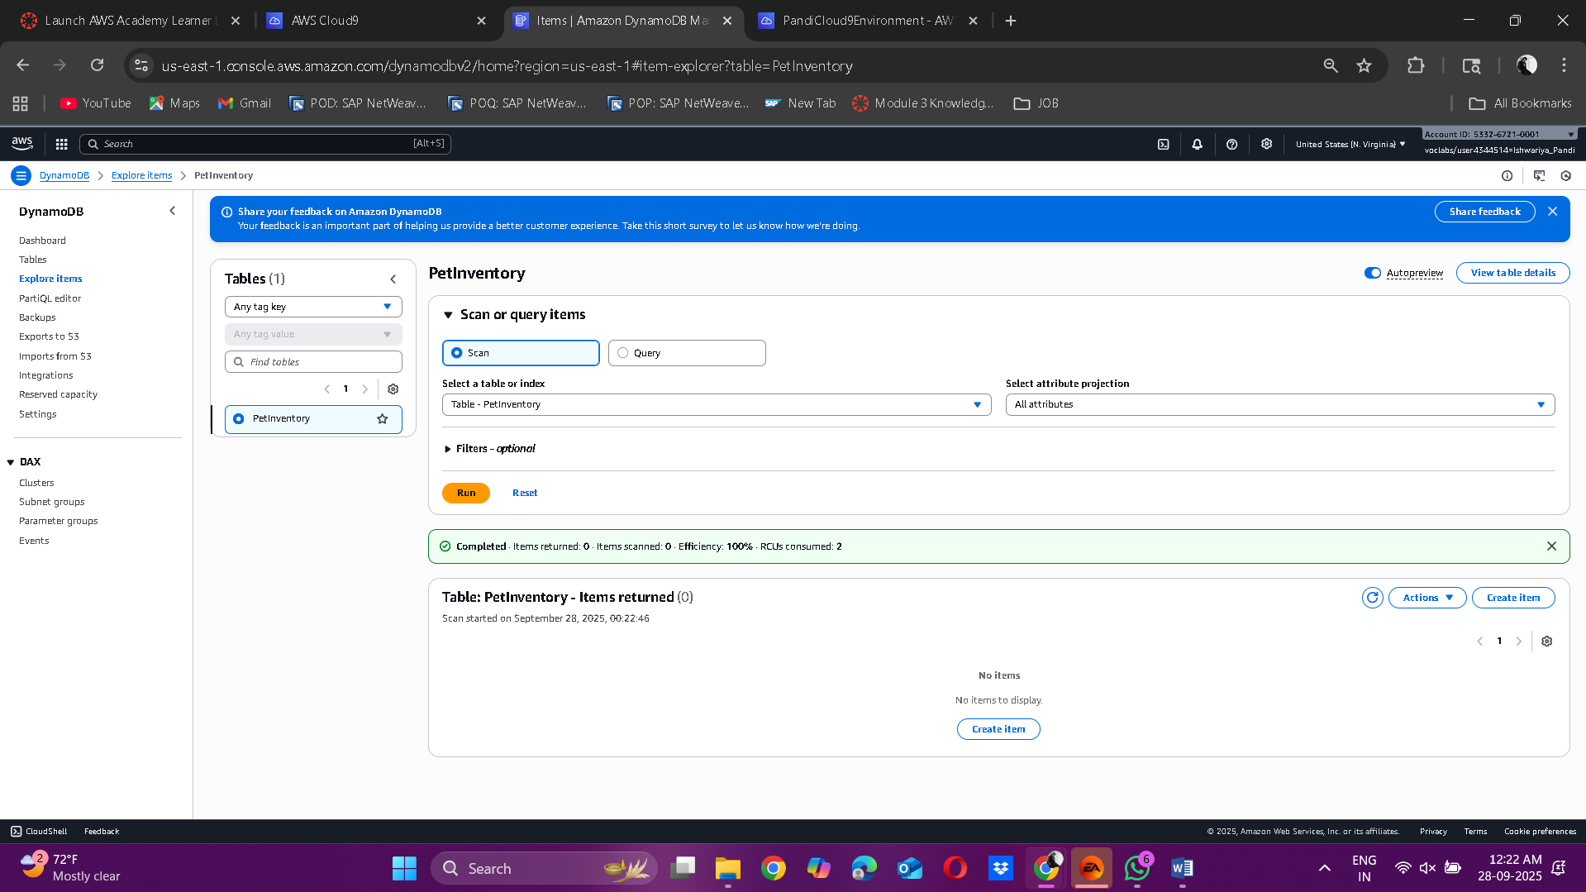

PART B: Create S3 Bucket & Insert Pet Data
6. Create S3 Bucket
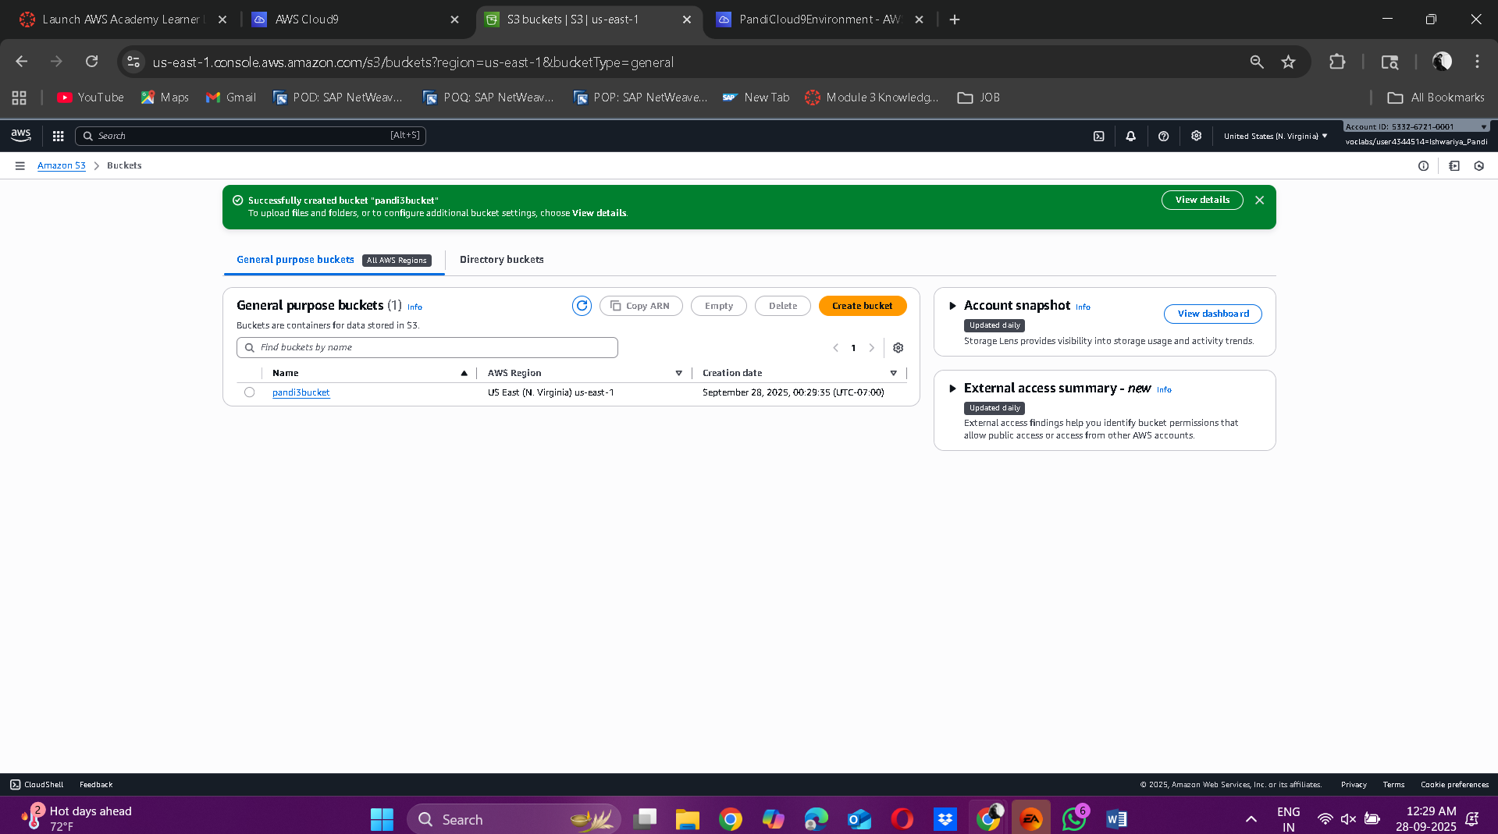

7. Insert Pets to DynamoDB
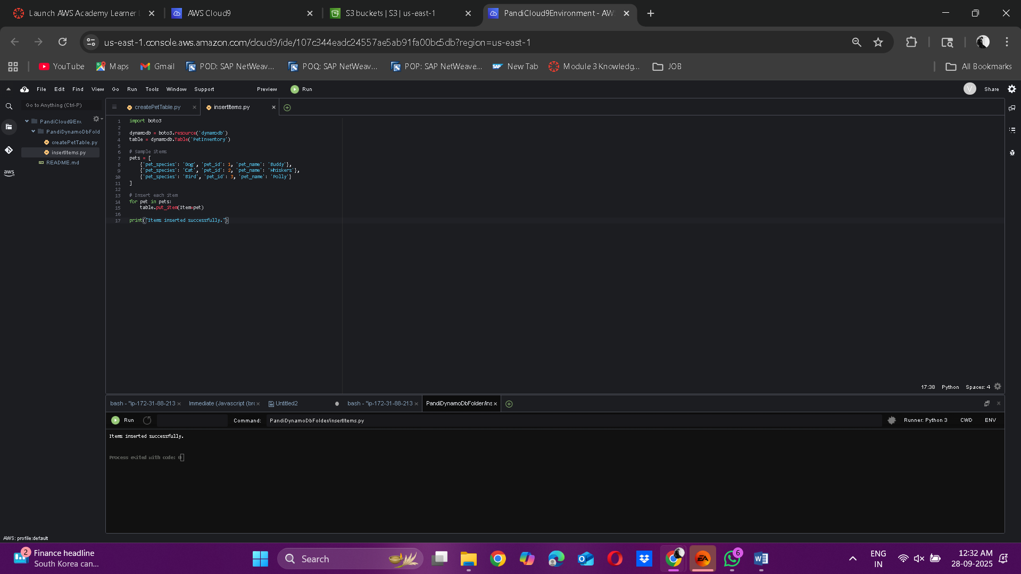

8. Export Table Items to S3
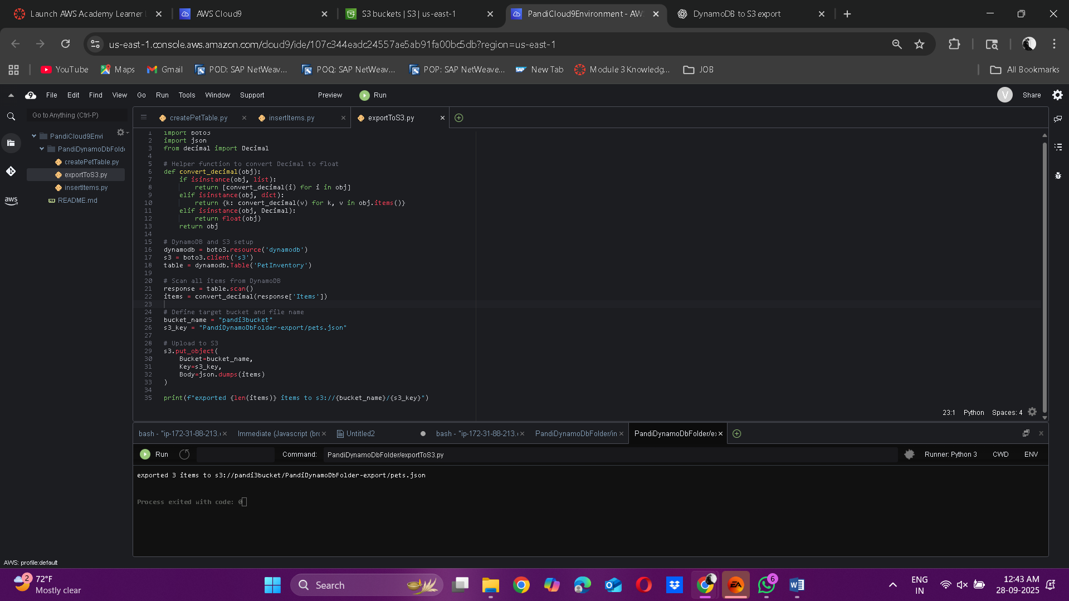

9. Verify it in your S3 bucket
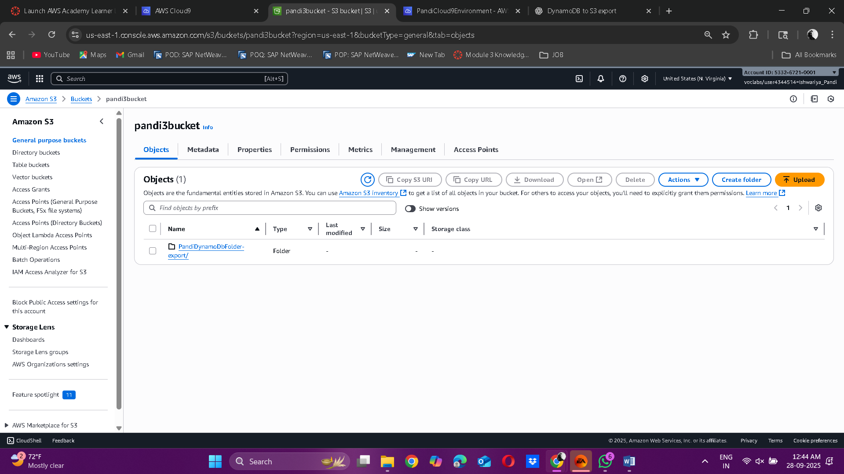

10. You will see pets.json
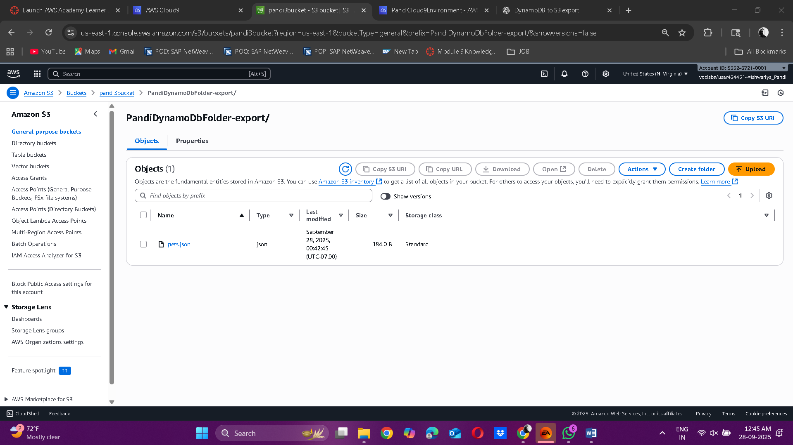

11. Verify In DynamoDB:
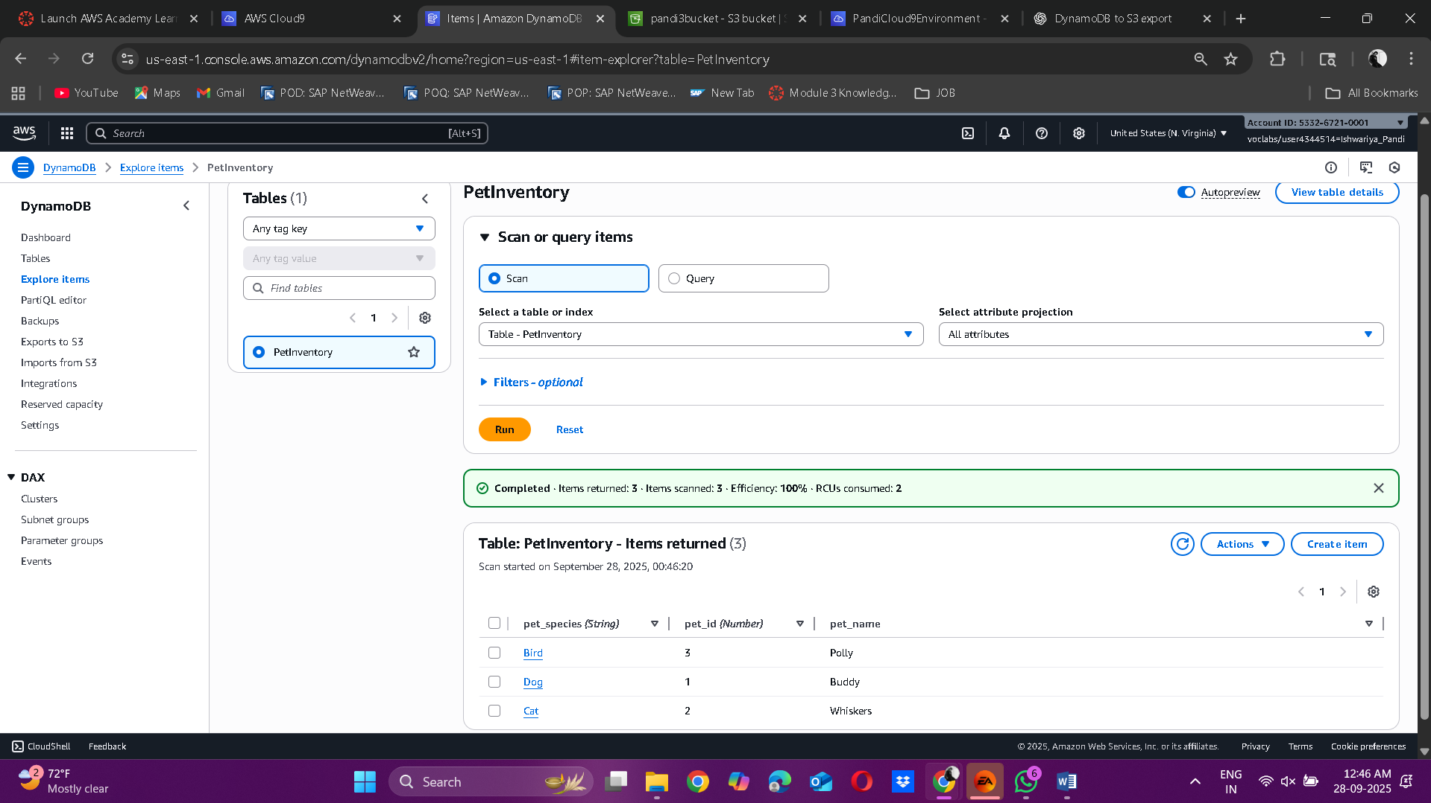

PART C: Query, Update, Delete and Display Data
12. Make queryPetTable.py
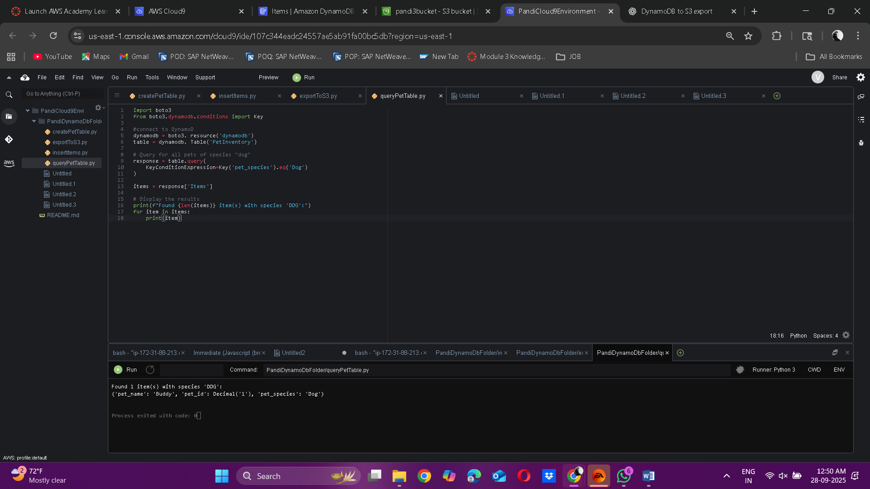

13. Update pet name
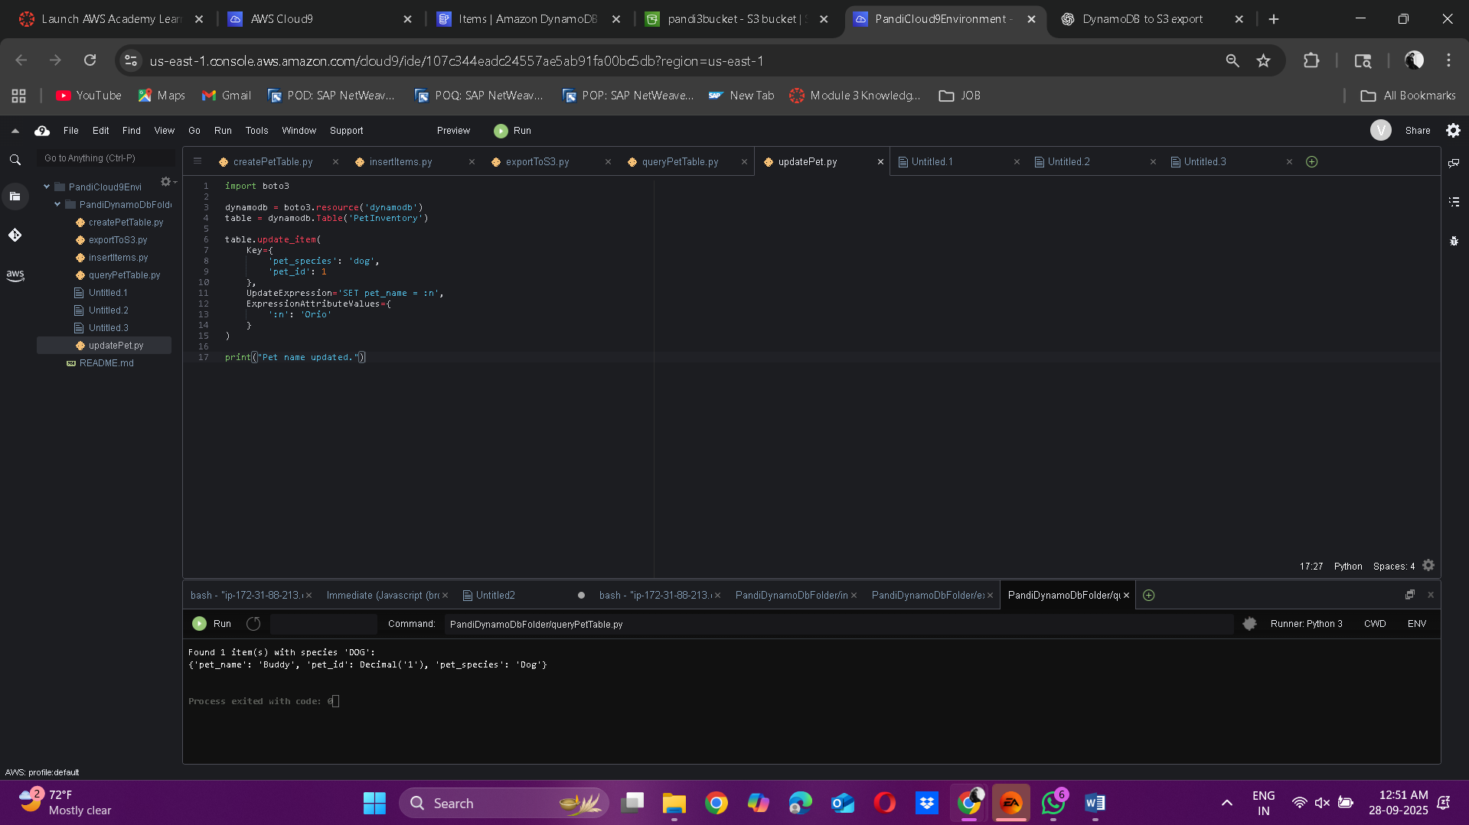
14. View All Items
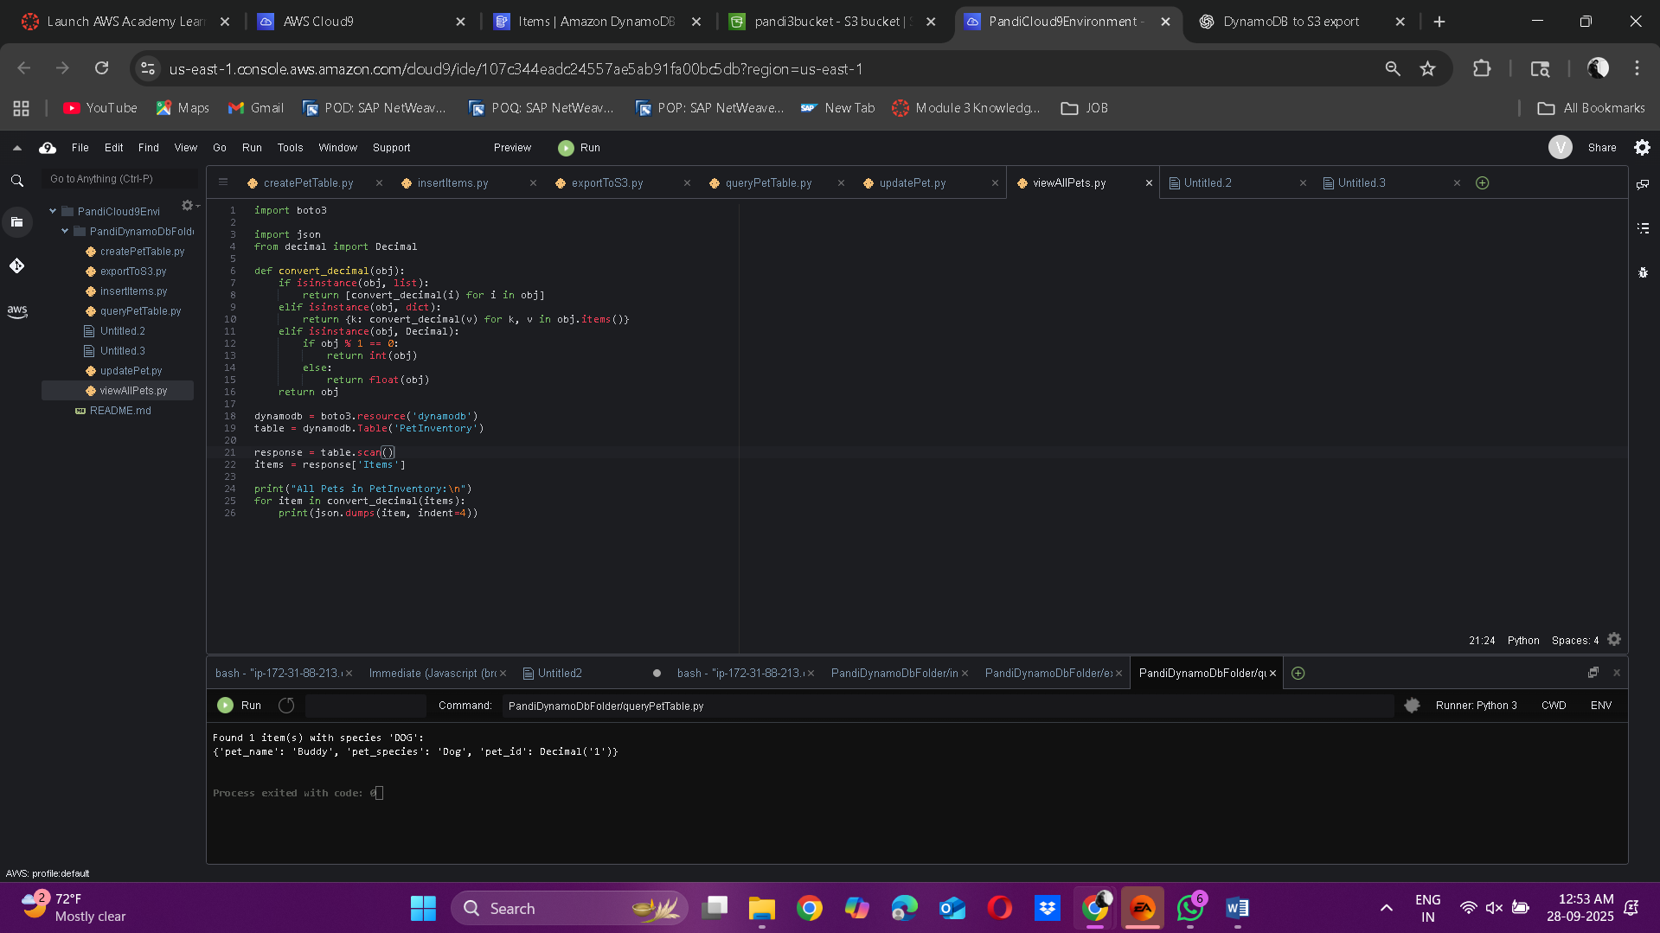

15. Delete Item
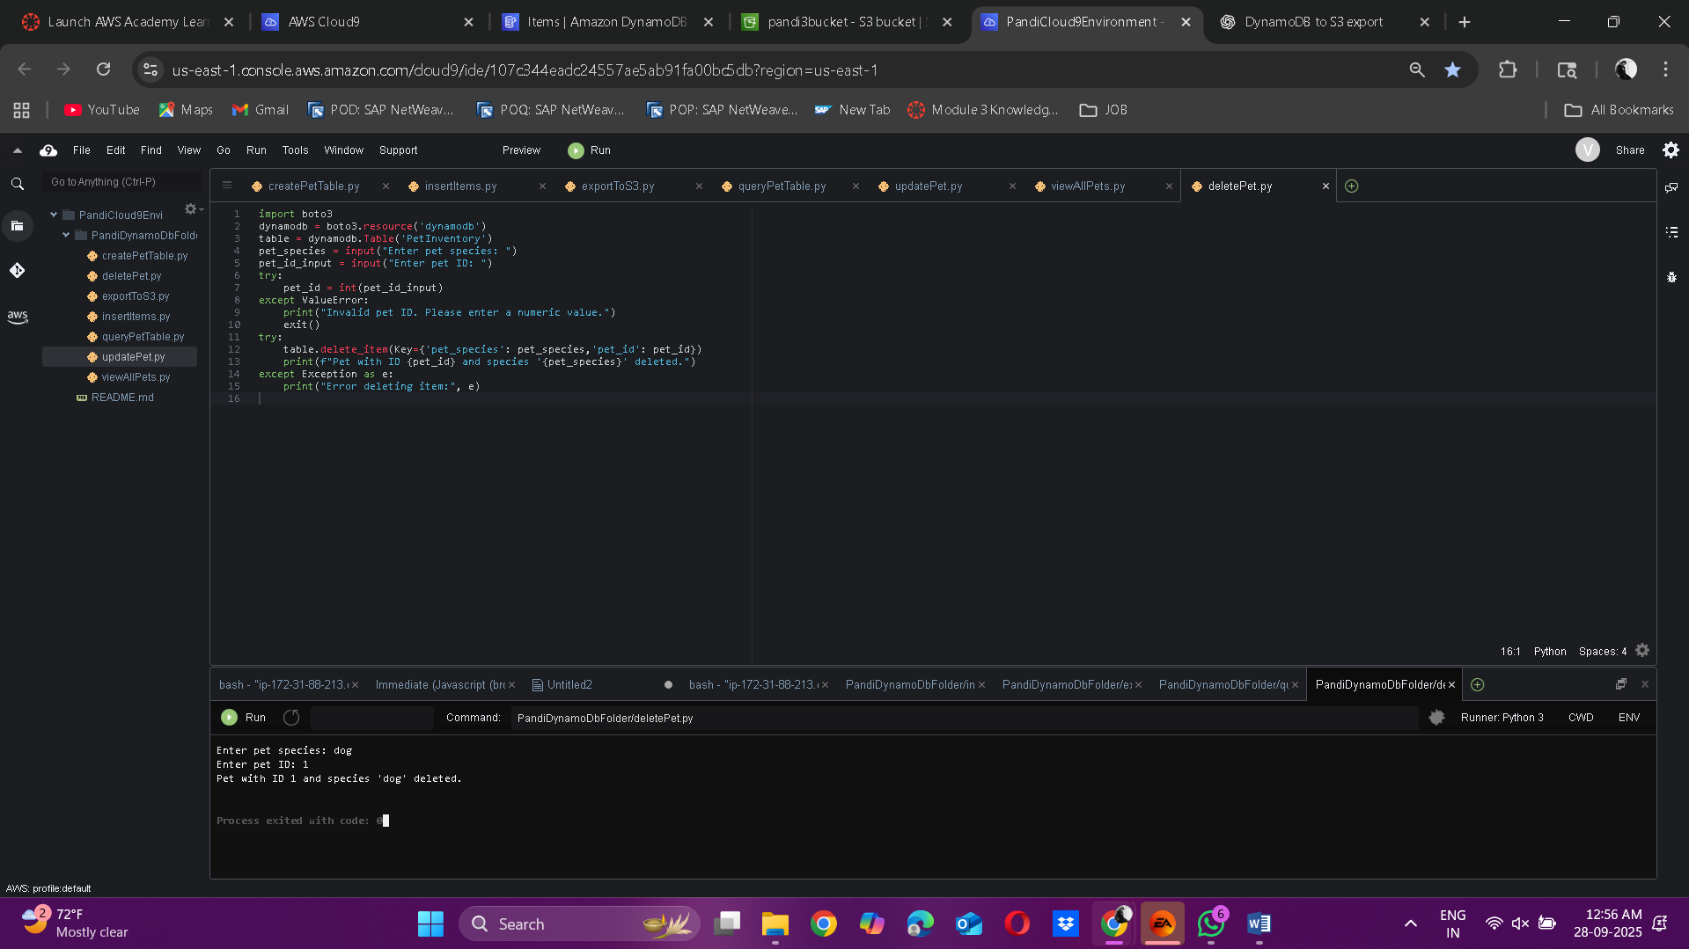

“Qns 3: In exportToS3.py, line 26 defines: s3_key = YourNameDynamoDbFolder-export/pets.json" Explain what this line does and where the file ends up”
“Ans:”
This line instructs AWS S3 on where to put the file within the bucket and what to call it. PandiDynamoDbFolder-export/ functions similarly to a directory path (technically a prefix in S3), while pets.json, the final component, is the filename. They combine to create the object key, which serves as the file's unique identifier in the bucket. The pets.json file will show up in the S3 bucket within the virtual folder PandiDynamoDbFolder-export/ once the script has finished running.
“Qns 4: Describe how this lab demonstrates the power of serverless development in AWS. How do DynamoDB, S3, and Cloud9 work together to simplify data storage and access?”
“Ans:”
The lab demonstrates how serverless tools can handle crucial functions like data processing and storage without requiring server management. S3 serves as a dependable location to store exported data files, DynamoDB offers quick and scalable database storage for structured data, and Cloud9 provides an online integrated development environment (IDE) that allows us to write code and execute scripts without requiring any local setup. When combined, they demonstrate how seamlessly AWS services work together: data can be managed with Cloud9, exported to S3, and created in DynamoDB without requiring infrastructure management.

